Fishbowl API Tool
User guide
A request workbench and SQL console for the Fishbowl Advanced REST API.
Built against Fishbowl Advanced API v26.9 · 20 September 2026

Contents

Contents 2
What this tool is, and why it is not Postman 4
Why not simply use Postman or Insomnia 4
What it is particularly good at 5
Fishbowl API development 5
Database troubleshooting 5
Getting connected 7
Servers 7
Signing in 7
Remembering a password 7
Pasting a token 8
Working offline 8
Working safely on production 9
Idle sign-out 9
Finding and sending a request 10
The endpoint list 10
The request form 10
Body and fields, side by side 10
Variables and capture 12
Capturing a value from a response 12
Saved requests 12
Importing data 14
The Data tab 15
The schema browser 15
Tables and views 15
The SQL editor 17
Colouring 17
Completion 17
Format SQL 18
Reading the response 19
Colouring by meaning 19
Sorting 20
Saving 20
Keeping and comparing results 21
What Compare shows 21
cURL, BI reports and access rights 23
Copy as 23
Access rights 23
Keeping the endpoint list current 25
What an update will and will not do 25
Example queries 26
A simple list 26
A join, to show qualified completion 26
A status breakdown, for comparing over time 26
On-hand inventory, written against the tables 26
The same answer through a view 27
A query with a variable 27
Reference 28
Keyboard 28
Where things are stored 28

What this tool is, and why it is not Postman
Two things in one window: a request workbench for every documented Fishbowl REST endpoint, and a SQL console against the same server. Both know what Fishbowl is, which is the whole point.
A generic API client can send a request to Fishbowl. What it cannot do is know anything about Fishbowl — which endpoints exist on the server in front of you, what an import expects, which access right a call needs, or what a status value means. That knowledge is the difference between sending a request and getting an answer.

Why not simply use Postman or Insomnia
Where a generic client stops | What this does instead
A collection someone has to build, export and keep in step with each release. | 107 endpoints are catalogued in the tool, and it updates itself from the server's own /apidocs.json. The server is the source of truth, so a collection cannot go stale.
Run from a browser or a page, and Fishbowl's responses cannot be read cross-origin at all. | Requests go out natively, so no Origin header is sent and the whole class of failure disappears. Self-signed certificates on customer servers are accepted.
An import is just a POST with a file. Which of the 67 record layouts, and which columns? | The import type is picked from the list the server actually accepts, and the column headers are fetched from that instance — including its custom fields.
A 403 tells you nothing about which right was missing. | The right an endpoint documents is shown before you send, ticked or crossed against the signed-in user.
No idea which server is production. | A server can be marked as holding real data: the window turns red and every write asks first.
SQL means a separate MySQL client, the database port, and credentials you may not have. | data-query is a first-class console here — schema-aware completion, results kept and compared over time, CSV export — over the same API session you are already using.

What it is particularly good at

Fishbowl API development
- Every endpoint arrives with its documented fields, an editable body template built from them, and the parameters it accepts — so a first attempt is an edit, not an invention.
- Variables and response capture turn Fishbowl's multi-step contracts into something you can actually run: create an order, capture its id, issue it, without copying numbers between windows.
- Copy as runRestApiAsync produces the exact call shape a BI report needs, with no token and no server address — the part people get wrong translating by hand.
- Copy as cURL produces something you can paste into a ticket, with the token replaced. Paste one back in and the form fills itself.
- The catalog carries notes the published documentation does not: which call consumes an order number, which field is a trap, which endpoint only exists after a given version.

Database troubleshooting
- Query the live database through the API account you already have. No MySQL port to open, no database credentials to obtain, and no second tool to install on a customer's machine.
- The schema browser is read from that instance, so it shows its custom fields and its version's tables, not a generic reference.
- Views are separated from tables, and the ones MySQL cannot filter cheaply are flagged before you write a query against one.
- Results are kept. A query against a live database cannot be re-run to get the same answer, so "was this number different an hour ago?" is only answerable if the earlier answer was written down. Compare says exactly which rows moved.
NOTE Nothing here replaces the Fishbowl API documentation, which answers a different question: what the endpoints do and how to build an integration on them. That guide is built into the tool under Documentation.
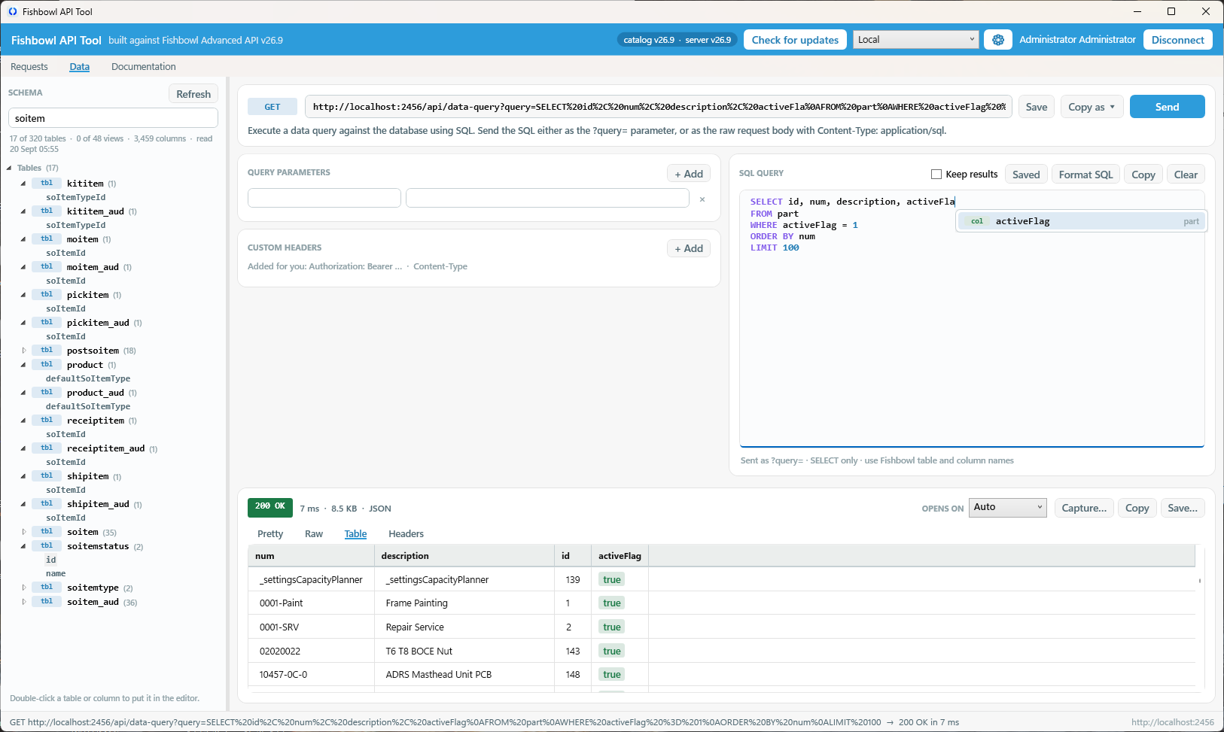Figure: The main window

Getting connected

Servers
The picker in the header switches between saved servers, each with its own address and integrated-app identity. The gear beside it adds, edits and removes them.
Switching servers disconnects you. A token belongs to a session on the server that issued it, and carrying it across would fail on the next call with a 401 that looks like an expired login.
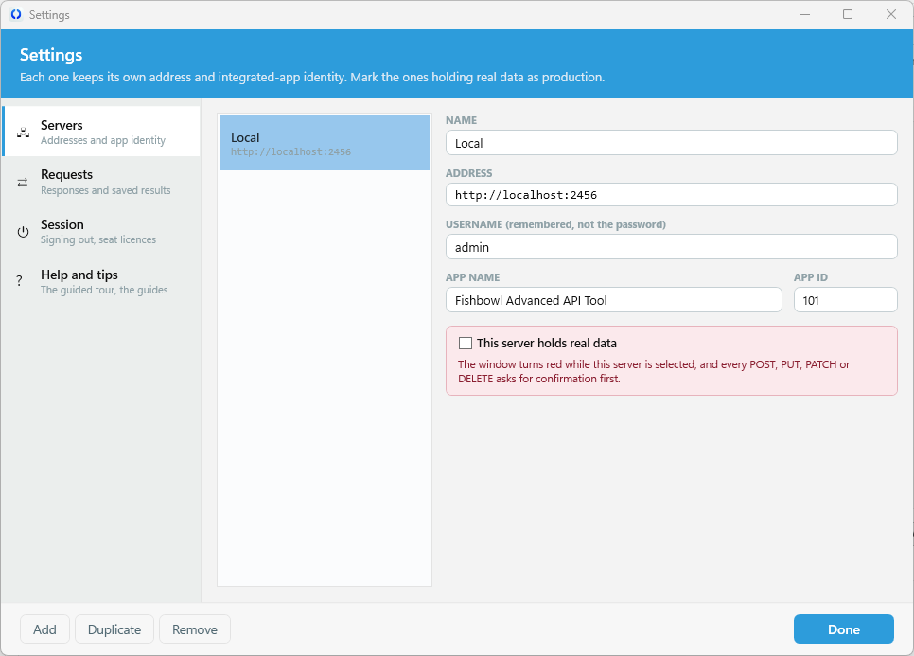
Figure: The Servers window

Signing in
The first sign-in with a given app name and id registers the app, and an administrator has to approve it in Fishbowl under Settings > Integrated Apps before it will work. Change the name or id under Integrated app identity only to reuse an approval that already exists.
WATCH OUT MFA arrives as a header, not a message. If the account has MFA enabled the server answers 401 with an MFA: Required header. Enter the code and sign in again — a wrong password looks exactly the same otherwise.

Remembering a password
Tick Remember this password and it is kept in the Windows Credential Manager: the per-user operating system vault, protected by your logon session, visible and revocable in Control Panel, and the same vault a password manager fills. This tool stores no password of its own.
It is saved only after the server accepts it. Storing one that turns out to be wrong is worse than storing none, because it comes back pre-filled and looking correct on every later attempt.
The entry is keyed on the server and the username together, because the same person routinely has different passwords on a sandbox and on a customer's server. Unticking the box, or Forget, removes it from the vault.
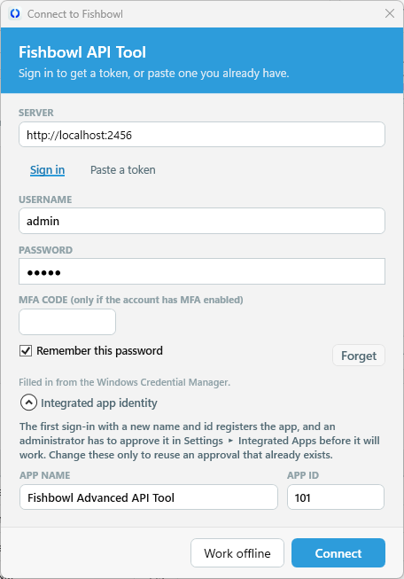
Figure: The Connect window

Pasting a token
The second tab takes a bearer token directly. This is not a shortcut: it is how you reproduce a failing call with the same session an integration used, which is usually the only way to tell an access-right problem apart from a payload problem.
A pasted token is tested before it is accepted, is never written to disk, and disconnecting drops it without logging that session out — the session belongs to whoever issued it.

Working offline
The endpoint list and both built-in documents work with no connection at all. Only sending a request needs one.

Working safely on production
This window sends real writes at real databases. Mark the servers that hold real data and the tool makes that impossible to forget.
- The header bar turns red and a banner names the server.
- Every POST, PUT, PATCH and DELETE asks for confirmation, naming the verb and the full URL.
The confirmation is per request rather than a session-wide acknowledgement. The point is to interrupt the one call that was not meant to go there, and a box ticked an hour ago interrupts nothing.
A new profile has the production box suggested from its address — anything that is not localhost and does not look like a sandbox. It is only ever a suggestion: a hostname is not evidence, and a copy of production called fishbowl-prod-copy would be flagged wrongly forever. You decide.
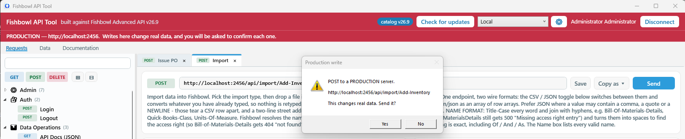Figure: Production warning

Idle sign-out
Fishbowl licences are seat-limited, so a session this tool is holding onto is a seat somebody else cannot have. After ten minutes of no activity a countdown appears; two minutes later the tool signs out and says why. Any mouse movement, key or scroll cancels it, as does Stay signed in.
Only a session the tool opened is ever ended. A pasted token is dropped locally and left alone on the server.
[ SCREENSHOT ] The idle countdown
The amber banner with the countdown and the Stay signed in button. Leave the window untouched for ten minutes with a connection open.
Figure: The idle countdown

Finding and sending a request

The endpoint list
The sidebar lists every catalogued endpoint by category. Search matches the name, the path, the category and the description. The three pills filter by verb, keeping their own colour and simply fading when switched off.
The same colours appear on the tab and in the URL bar, because the verb is what decides whether a call is safe to fire at a live server: blue reads, green writes, red destroys.
Double-click an endpoint to open it. Each opens in its own tab, so looking up a part id half way through composing a sales order no longer throws the order away.

The request form
- Path parameters are the {id} parts of the URL. An unfilled one stays visible in the preview rather than collapsing into something that looks valid and then 404s.
- Query parameters that are documented are laid out for you; hover a field for what it means. Add your own with + Add. A parameter with no value is left out entirely.
- Custom headers are rarely needed. Authorization and Content-Type are added for you.

Body and fields, side by side
The body editor and the documented field list sit next to each other, because writing a body while reading which fields are required is the main thing anyone does here. Reset puts the documented template back; Fields hides the list when you want the width.
On a GET with a documented field list there is no body to write — those fields describe what comes back — so the pane becomes a response reference instead.

NOTE Enter sends, from any single-line field. Inside the body, SQL and import editors Enter is a new line and Ctrl+Enter sends: losing a half-typed body to a stray keystroke costs more than the shortcut saves.
Invalid JSON is caught before the request goes out, with the actual parse error. The server would only answer 400 with something less useful.
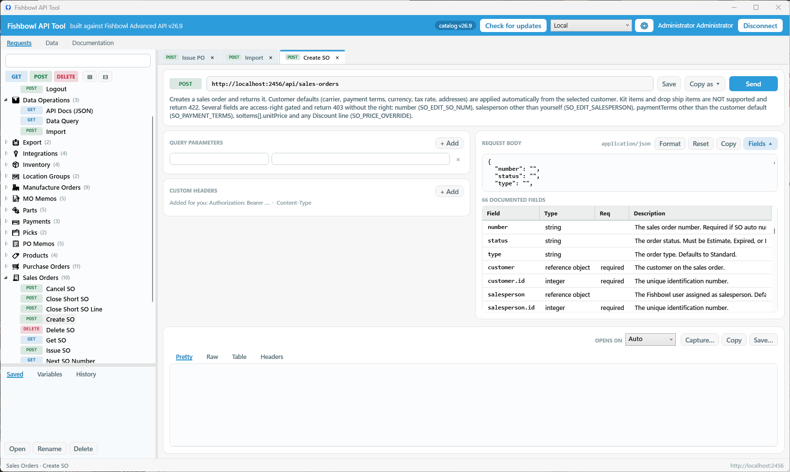Figure: A request being composed

Variables and capture
Write {{name}} in any field — a path parameter, a query value, a header, a body, a SQL statement — and it is replaced when the request is sent. The Variables panel at the bottom of the sidebar holds them, and the panel can be dragged taller.

WATCH OUT An unknown name is not replaced. Sending is refused instead, naming the ones with no value. Substituting an empty string would build a URL that looks perfectly valid and quietly asks for the wrong record.

Capturing a value from a response
This is the part that matters. Fishbowl's own contracts force multi-step work — create a manufacture order, read back its id, issue it; create a sales order, then add a memo to it — and the id in the middle exists only in the response you just received.
Capture on the response bar lists the fields in that response, shows what each holds, and puts the one you pick into a variable. Tick Do this automatically from now on and it repeats every time that request succeeds, so a sequence keeps itself up to date.
Paths are written id, customer.name, results[1].num. A path that does not start at an array is also tried inside results, because every search endpoint wraps its rows in that envelope.
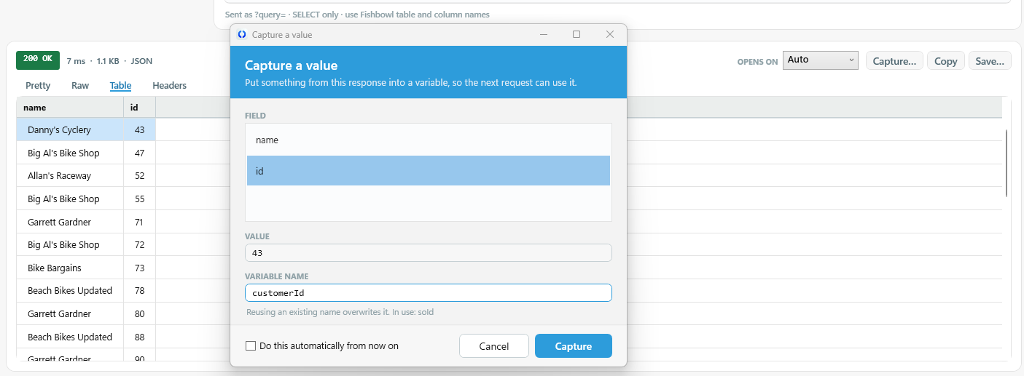Figure: Capturing a value
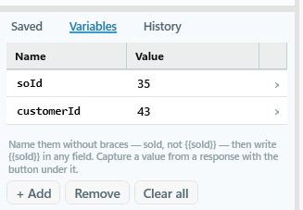
Figure: The Variables panel

Saved requests
Save in the request bar keeps a filled-in request by name; the Saved panel opens them again. History is still there for the last sixty calls, but it dies with the session and is ordered by accident — this is for the handful you run every day.
They are stored with the placeholders intact rather than with whatever those resolve to right now, so one saved request works against every server instead of being welded to the one it was recorded on. Capture rules are saved with it.

Importing data
The import endpoint is one endpoint covering 67 different record layouts, so it gets a pane of its own.
- Import type: click anywhere in the box to open the list. These are the only names the server accepts, spelled exactly; each is labelled with the directions it supports.
- Headers: picking a type asks the server for that type's header row and lays out a template. The layouts are documented, but asking the server gives you this instance's columns — including its custom fields, in its own order — so it is what this database will actually accept.
- CSV or JSON: the toggle converts what is already typed rather than discarding it, and sets the right Content-Type.
- Files: drop a .csv, .txt or .json anywhere on the pane. The format is decided by what is in the file, not by its extension.
WATCH OUT The JSON form is a 2-D array, not an array of objects. The first inner array is the header row. Sending objects is the usual first mistake; paste them anyway and they are converted for you.
[
["PartNumber", "Description", "UOM"],
["WIDGET-A", "Large widget", "ea"]
]
The JSON import shape: headers first, then one array per row.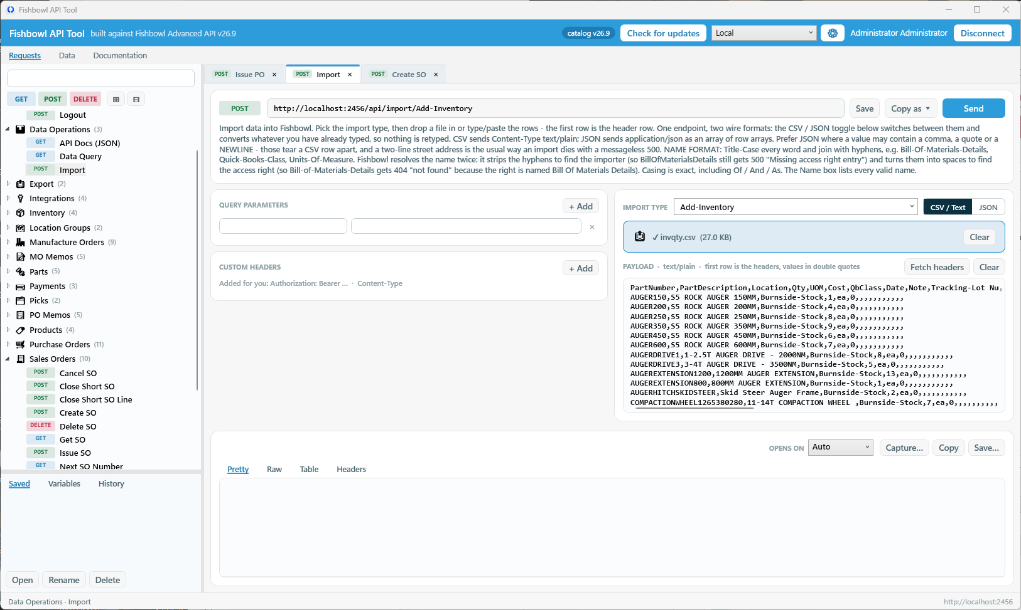Figure: The Import pane

The Data tab
The query endpoint has a tab of its own, because it carries an editor, kept results and a comparison view and is nothing like the other endpoints. It is the same pane the endpoint opens in the sidebar — one implementation, not a copy — so the endpoint still works from the sidebar exactly as before.

The schema browser
Down the left, everything in the connected database, read from the server so it shows this instance's custom fields. Tables and views are listed separately.
The filter matches two ways, and the second is the useful one: type part of a table name to find the table, or type a column name to find the tables that have it. Those arrive already expanded showing just the columns that matched, because working out which table holds qtyCommitted is most of what anyone opens this for.
Double-click a table or column to drop it into the editor at the caret. Columns arrive qualified, because that is what a join needs and deleting a qualifier is the easier of the two edits.

Tables and views
Views carry a view pill, and some of them carry a second one: materialises.
MySQL runs a view one of two ways. Normally it folds your WHERE into the view's own query, so indexes apply. But a view built with GROUP BY, UNION or DISTINCT cannot be treated that way: MySQL assembles the entire view into a temporary table first and filters the result afterwards. The work is then proportional to the whole view rather than to what you asked for.
On a current Fishbowl database that is 27 of the 48 views. The badge is worked out from each view's own definition, so it stays correct per database and per version.

NOTE For a quick look, ignore it — a few hundred milliseconds does not matter. For anything in a report or a loop, write the query against the underlying tables with your filter inline. The examples at the end of this guide show both forms.
Figure: The Data tab
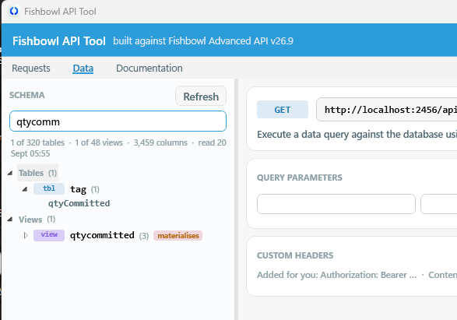
Figure: Finding a column

The SQL editor

Colouring
Keywords purple, string literals green, numbers blue, comments grey italic. It re-colours shortly after you stop typing, so it never fights the caret.

Completion
Type two letters and a list appears under the caret. Each row says what it is offering and where it comes from: a column names its table on the right, a table says how many columns it has, a keyword says so.
What is offered depends on where you are in the statement:
Where the caret is | What is offered first
Straight after FROM or JOIN | Table and view names only — nothing else is legal there
In a SELECT list, WHERE, ON or ORDER BY | Columns, then keywords, then tables
At the start of a statement | Keywords
After a table or alias and a dot | That table's columns, and nothing else

Columns come from the tables the statement actually names. Offering every column in the database once a FROM is written would bury the handful that could be meant under thousands that could not.

NOTE Tab accepts. Up and Down move, Esc dismisses, Ctrl+Space asks without waiting for a second letter. Enter is always a new line — binding it would turn every line break that happens to follow a word into a completion nobody asked for.
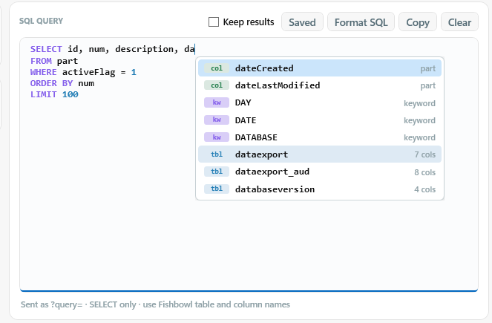
Figure: Completion in context
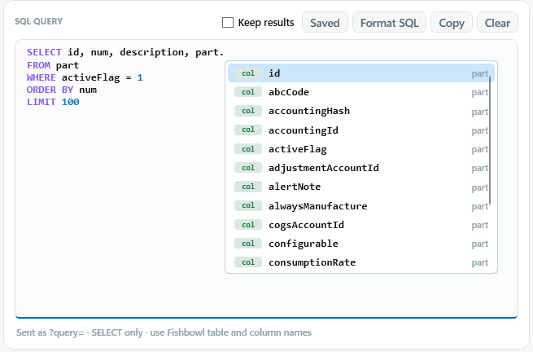
Figure: Qualified completion

Format SQL
Uppercases the reserved words, puts each clause on its own line, indents AND and OR under their condition, and tidies the spacing — COUNT(*) rather than COUNT (*), no space before a comma.

WATCH OUT The formatter never touches a literal or a comment. It works on parsed tokens rather than raw text, so WHERE note = 'select from where' comes back exactly as you wrote it. A find-and-replace formatter would change what that query matches.
Only SELECT is allowed by the server.

Reading the response
Tab | What it shows
Pretty | Indented, coloured JSON
Raw | Exactly what came back, unaltered
Table | Rows, for anything that has them
Headers | The response headers

Opens on sets which tab a response lands on and is remembered across sessions. Auto shows the table for a query with rows and Pretty for everything else. A chosen tab is stepped past where it makes no sense: opening on an empty Table because that is the preference would hide the error the response actually contains.

Colouring by meaning
Recognised values are coloured by what they mean, in both the table and the JSON view, grouped by what the news is rather than by which module it came from.
Reads as | Examples
Done | Fulfilled, Shipped, Received, Approved, true
Under way | Issued, In Progress, Picking, Scheduled
Wants a human | Pending Approval, Closed Short, Expired
Stopped or undone | Voided, Cancelled, Rejected, false
Not started | Entered, Draft, Historical

Matching is exact, never by substring: a coloured chip around part of a description would be a lie. Unrecognised values stay plain, and empty cells read muted.

Sorting
Click a column header. Every cell arrives as a string, so sorting them as text would give 10, 15, 2, 20 on an id column. Instead numbers sort as numbers, ISO dates chronologically, and text as text. Money and percentages count as numbers, and blanks gather at one end.
The decision is made per pair of values rather than per column, so one N/A in a quantity column does not push the rest back to text sorting.

Saving
Save offers CSV and JSON for anything tabular; pick the type in the dialog and the format follows. CSV quotes every field, so a part number like 00123 keeps its leading zeros instead of arriving in a spreadsheet as 123.
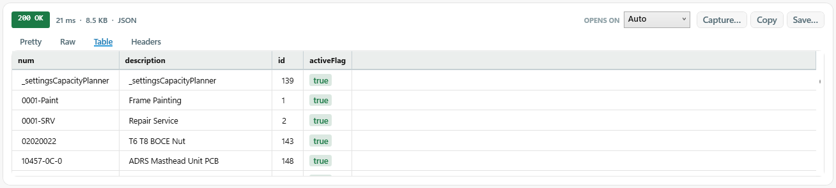Figure: A response table

Keeping and comparing results
A query run against a live database cannot be re-run to get the same answer. That is the whole reason for keeping one: "was this number different an hour ago?" is unanswerable unless the earlier answer was written down.
Keep results stores each successful query on this machine — the last forty, oldest dropped as new ones arrive. Saved shows them.
Action | What it does
Double-click | Loads that result back into the response pane. The badge reads kept Tue 14:22, not a fresh 200 OK.
Restore query | Puts its SQL back in the editor
Rename | Labels a run, for telling two similar ones apart
Compare | Diffs the selected run against what the response pane is showing now

What Compare shows
The differences go into the response pane itself, so they sort, copy and save like any other result. A marker column tags each row:
- Plus — in the current result only
- Minus — in the kept result only
- Tilde — in both, but changed. Only the fields that moved show old and new, so the row stays recognisable.
Rows are matched on a key column so an edited row reads as one change rather than a deletion plus an insertion. The key is chosen by evidence rather than by name: the first column whose values are unique and complete on both sides. A column called id that repeats — any join will do that — is rejected, because using it would pair unrelated rows and report nonsense. Without a key it compares whole rows and says so.
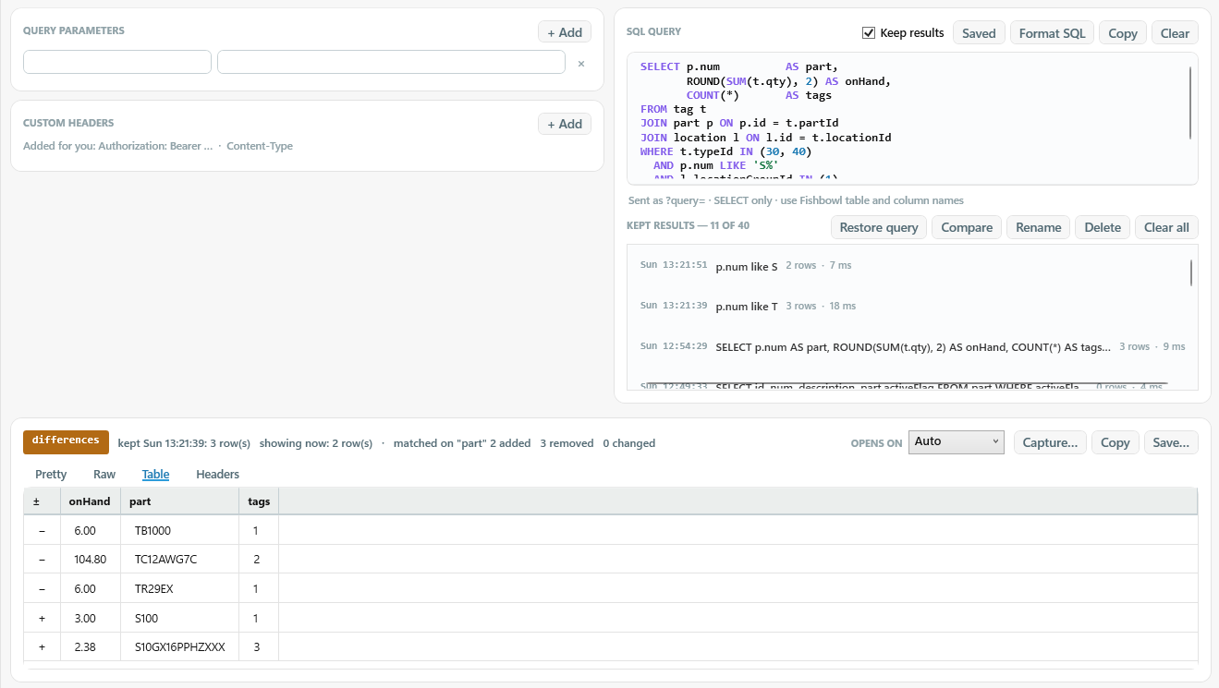Figure: A comparison

cURL, BI reports and access rights

Copy as
Format | For
URL | The address as it will be sent
cURL command | Pasting into a ticket or a chat. The token is replaced with a placeholder — a live session token pasted into a ticket is a credential leak, so it is never included, even though that leaves the command one edit short of runnable.
runRestApiAsync call | Pasting into a BI report. A report runs inside the Fishbowl client and uses the session the client already holds, so the snippet carries no token and no server address.

Fill in from a cURL command works the other way: copy the command a colleague ran and the form fills itself in. Anything the command carries that this endpoint does not document still comes across as an extra row rather than being dropped.

Access rights
Where an endpoint's description names the right it needs, a chip under the description says so — green when the signed-in user has it, red when they do not.
A 403 from Fishbowl does not say which right was missing, so the usual next step is guessing whether the payload is wrong or the account is, and that guess costs far more than the call did.

NOTE Nothing is inferred from a path. If the documentation names a right the tool does not recognise, the chip says what was documented and makes no claim about whether you have it — a wrong prediction would send someone to an administrator to fix a permission that was never the problem.

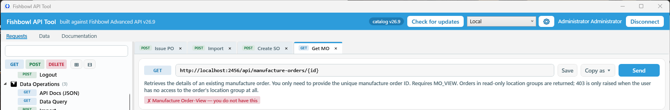Figure: The access-right chip

Keeping the endpoint list current
Nothing about an endpoint is built into the program. The sidebar, the forms, the field tables and the body templates are all generated from a catalog, and the catalog can be brought up to date from the server's own documentation — so a newer server's endpoint is a new record, not a new release.
The tool checks quietly at start-up and says so in the status bar. Check for updates opens the review, which lists every proposed change with its own checkbox.

What an update will and will not do
- Adds endpoints the server documents and the catalog does not.
- Refreshes parameters, fields and body templates on endpoints that already exist.
- Leaves the wording alone. The catalog's descriptions carry notes the published text does not, so only shape is compared.
- Removes nothing automatically. An endpoint the server does not mention is usually a curated addition, or an older server; those arrive unticked and need a second confirmation.
Reset to the shipped catalog throws every applied update away.
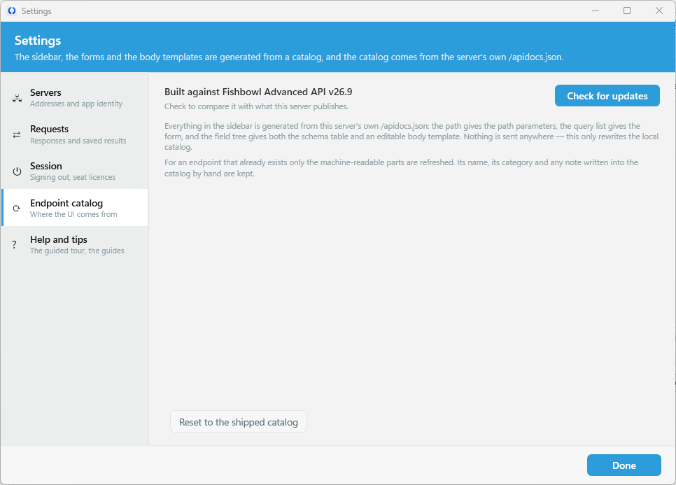
Figure: The update review

Example queries
These are written as the Format SQL button produces them, and are good subjects for the screenshots above. All are read-only.

A simple list
SELECT id, num, description
FROM part
WHERE activeFlag = 1
ORDER BY num
LIMIT 100
Good for a first screenshot: small, fast, and the Table view fills.

A join, to show qualified completion
SELECT so.num, c.name, so.totalPrice, so.dateCreated
FROM so
JOIN customer c
ON c.id = so.customerId
WHERE so.statusId IN (20, 25)
ORDER BY so.dateCreated DESC
LIMIT 50
Type c. part way through and the completion list offers only customer's columns.

A status breakdown, for comparing over time
SELECT statusId, COUNT(*) AS orders
FROM so
GROUP BY statusId
ORDER BY statusId
Run it, change an order in Fishbowl, run it again, then Compare against the kept run.

On-hand inventory, written against the tables
SELECT p.num, p.description, SUM(t.qty) AS onHand
FROM tag t
JOIN part p
ON p.id = t.partId
WHERE t.typeId IN (30, 40)
GROUP BY p.num, p.description
HAVING onHand > 0
ORDER BY onHand DESC
LIMIT 25
The filter is applied before the aggregation, so the index on tag.partId is used.

The same answer through a view
SELECT *
FROM qohview
WHERE partId = 1
Shorter, and marked materialises in the browser: MySQL builds the whole view before applying the WHERE. Fine for a look, poor inside a report.

A query with a variable
SELECT num, description, activeFlag
FROM part
WHERE id = {{partId}}
Set partId in the Variables panel, or capture it from a search response first.

Reference

Keyboard
Key | Does
Enter | Sends, from any single-line field
Ctrl+Enter | Sends from inside the body, SQL or import editor
Tab | Accepts the highlighted completion
Ctrl+Space | Asks for completions without waiting for a second letter
Up / Down | Moves through the completion list
Esc | Dismisses the completion list
Double-click | Opens an endpoint, a saved request, a kept result, or inserts a schema name

Where things are stored
Path | What is in it
%LOCALAPPDATA%\FbApiTool\settings.json | Server, username, app identity, preferences. No password, no token.
%LOCALAPPDATA%\FbApiTool\catalog.json | The updated catalog, once an update has been applied
%LOCALAPPDATA%\FbApiTool\profiles.json | The servers, and which are marked production
%LOCALAPPDATA%\FbApiTool\variables.json | Variables and their current values
%LOCALAPPDATA%\FbApiTool\requests.json | Saved requests, with their placeholders intact
%LOCALAPPDATA%\FbApiTool\queries\ | Kept query results — an index and one file per result
%LOCALAPPDATA%\FbApiTool\schema-*.json | Cached tables and columns, one file per server
Windows Credential Manager | Remembered passwords. Not a file, and not this tool's to encrypt.

WATCH OUT Kept results and variables are real data — query output from a live database, and whatever you captured, sitting unencrypted in your profile. Clear all removes each of them. Turning Keep results off stops new ones being written but leaves what is already there.
Tokens are never written to disk, in either connection mode.
This guide documents the tool. For the API itself — what the endpoints do and how to build an integration on them — see the Fishbowl API guide, built into the tool under Documentation.

